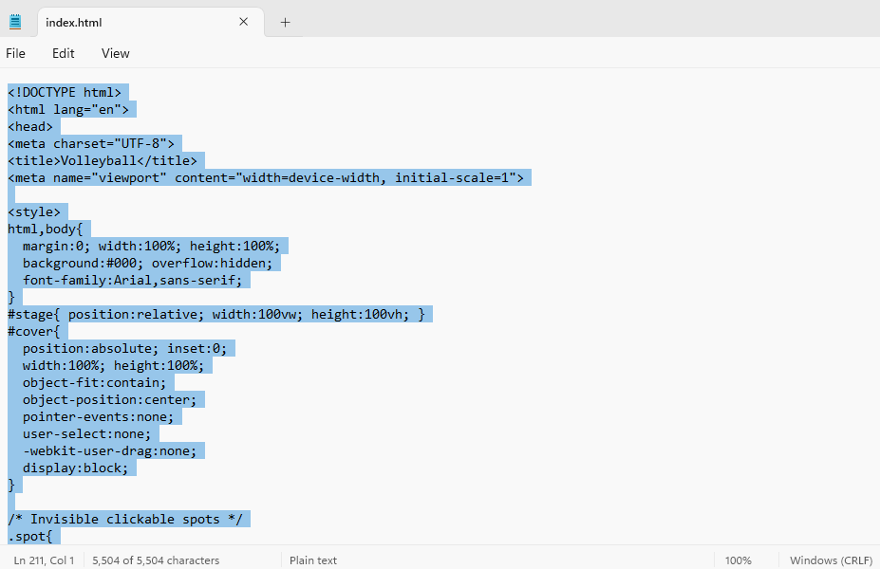
Main Page “index.html”
Code for page “index.html”, notepad

<!DOCTYPE html>
<html lang="en">
<head>
<meta charset="UTF-8">
<title>Volleyball</title>
<meta name="viewport" content="width=device-width, initial-scale=1">

<style>
html,body{
margin:0; width:100%; height:100%;
background:#000; overflow:hidden;
font-family:Arial,sans-serif;
}
#stage{ position:relative; width:100vw; height:100vh; }
#cover{
position:absolute; inset:0;
width:100%; height:100%;
object-fit:contain;
object-position:center;
pointer-events:none;
user-select:none;
-webkit-user-drag:none;
display:block;
}

/* Invisible clickable spots */
.spot{
position:absolute;
border-radius:50%;
transform:translate(-50%,-50%);
z-index:3;
cursor:pointer;
background:transparent;
outline:none;
}
.spot:focus-visible{
outline:3px solid rgba(255,230,0,.95);
outline-offset:4px;
}

/* Debug overlay */
body.debug .spot{
background:rgba(0,255,255,.20);
outline:2px dashed cyan;
}

/* Jumper (PNG) */
#jumper{
position:absolute;
width:90px; height:90px;
background:url("jumper.png") center/contain no-repeat;
pointer-events:none;
z-index:6;
filter:drop-shadow(0 14px 16px rgba(0,0,0,.4));
}

/* Glow trail */
.trail{
position:absolute;
width:18px; height:18px;
border-radius:50%;
transform:translate(-50%,-50%);
background:radial-gradient(circle,#fff8a8,#ffd200 45%,rgba(255,210,0,0) 70%);
pointer-events:none;
z-index:5;
animation:fade 0.7s linear forwards;
}
@keyframes fade{
to{opacity:0; transform:translate(-50%,-50%) scale(2.2);}
}
</style>
</head>

<body>
<div id="stage">
<img id="cover" src="Coverpage-neu.png" alt="Volleyball cover">
<div id="jumper" aria-hidden="true"></div>
</div>

<script>
/* Debug toggle: index.html?debug=1 */
const params = new URLSearchParams(location.search);
if (params.get("debug") === "1") document.body.classList.add("debug");

/* Your ball positions */
const balls = [
{label:"Volleyball history", x:19,y:25,r:150,href:"history.html"},
{label:"Volleyball today", x:13,y:43,r:150,href:"international_volleyball_today.html"},
{label:"Health & Volleyball", x:18,y:59,r:165,href:"health_volleyball.html"},
{label:"Who can play volleyball?", x:78,y:28,r:155,href:"who.html"},
{label:"Championships & Stars", x:63,y:43,r:170,href:"volleyball_business.html"},
{label:"Beach Volleyball", x:87,y:45,r:170,href:"beach.html"},
{label:"How to improve", x:71,y:60,r:170,href:"improve.html"},
{label:"", x:86, y:60, r:170, href:"from_basics_to_perfection.html"},
{label:"Volleyball at EIS", x:61,y:72,r:145,href:"eis.html"},
{label:"Check your progress", x:74,y:83,r:175,href:"progress.html"},
{label:"Bibliography and contact", x:16,y:84,r:210,href:"bibliography_contact.html"}
];

const stage = document.getElementById("stage");
const img = document.getElementById("cover");
const jumper = document.getElementById("jumper");

/* Map object-fit:contain visible image rectangle */
function imageRect(){
const sw = stage.clientWidth, sh = stage.clientHeight;
const iw = img.naturalWidth || 1, ih = img.naturalHeight || 1;
const sr = sw/sh, ir = iw/ih;
let w,h,x,y;
if(ir > sr){ w = sw; h = sw/ir; x = 0; y = (sh-h)/2; }
else { h = sh; w = sh*ir; y = 0; x = (sw-w)/2; }
return {x,y,w,h};
}

/* Scale helper for hotspot diameter */
function responsivePx(px){
const minDim = Math.min(stage.clientWidth, stage.clientHeight);
const scale = Math.max(0.78, Math.min(1.18, minDim / 900));
return Math.round(px * scale);
}

/* Build hotspots */
function buildSpots(){
document.querySelectorAll(".spot").forEach(e=>e.remove());
const r = imageRect();

balls.forEach(b=>{
const a = document.createElement("a");
a.className = "spot";
a.href = b.href;
a.setAttribute("aria-label", b.label);
a.title = (params.get("debug") === "1") ? b.label : "";

const cx = r.x + (b.x/100)*r.w;
const cy = r.y + (b.y/100)*r.h;

a.style.left = cx + "px";
a.style.top = cy + "px";

const d = responsivePx(b.r);
a.style.width = d + "px";
a.style.height = d + "px";

stage.appendChild(a);
});
}

/* ===== Jumper hopping ===== */
let idx = 0;
let pos = {x:0,y:0};

/* speed controls (slower = smaller STEP and/or longer WAIT) */
const STEP = 0.012; // was 0.018 (slower)
const WAIT = 1500; // was 1200 (slower)
const ARC = 110; // jump height

function trail(x,y){
const t = document.createElement("div");
t.className = "trail";
t.style.left = x + "px";
t.style.top = y + "px";
stage.appendChild(t);
setTimeout(()=>t.remove(), 700);
}

function hop(){
const r = imageRect();
const b = balls[idx];

const tx = r.x + (b.x/100)*r.w;
const ty = r.y + (b.y/100)*r.h;

let t = 0;
const sx = pos.x, sy = pos.y;

function anim(){
t += STEP;

if(t >= 1){
pos = {x:tx, y:ty};
idx = (idx + 1) % balls.length;
setTimeout(hop, WAIT);
return;
}

const x = sx + (tx - sx)*t;
const y = sy + (ty - sy)*t - Math.sin(t*Math.PI)*ARC;

jumper.style.transform = `translate(${x - 45}px, ${y - 45}px)`;
trail(x,y);
requestAnimationFrame(anim);
}
anim();
}

img.onload = ()=>{
buildSpots();

const r = imageRect();
pos.x = r.x + (balls[0].x/100)*r.w;
pos.y = r.y + (balls[0].y/100)*r.h;

jumper.style.transform = `translate(${pos.x - 45}px, ${pos.y - 45}px)`;
setTimeout(hop, 900);
};

window.addEventListener("resize", buildSpots);
</script>
</body>
</html>

